TESTIMONIALS FOR WEBSITE

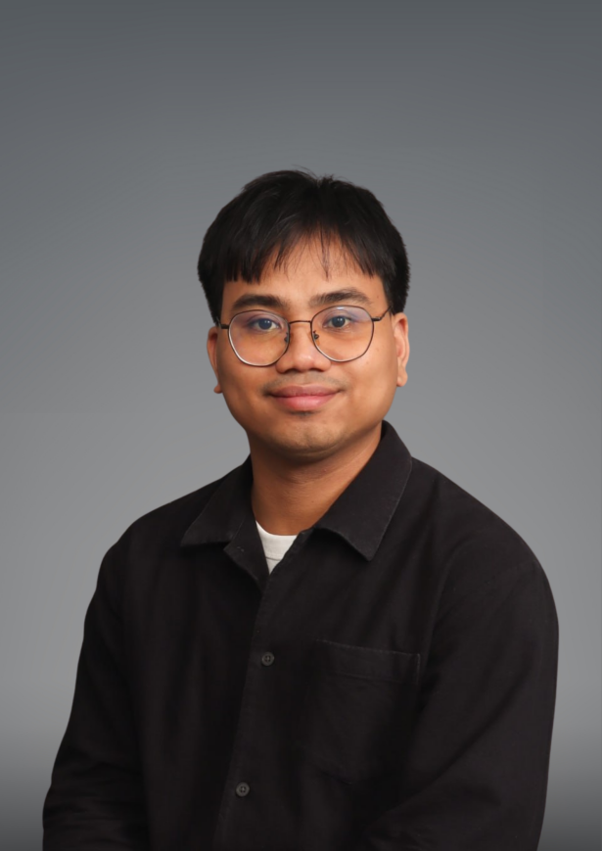 | “As a fresh graduate, without a single job experience in the construction industry, I lacked confidence in my abilities to design and manage real projects. But Espacio Diseño Inc. saw potential in me that I didn’t see in myself before. Espacio Diseño Inc. taught me everything I know about the industry, and with their help, I can now handle projects by myself.”  -Michael Sulla  Junior Project Planning Architect
 | “Working at Espacio Diseño Inc. has been a transformative experience that has greatly enhanced my career. The company's vibrant culture fosters creativity and collaboration, allowing me to tackle diverse design projects that expand my skills and versatility. With strong support from leadership and numerous professional development opportunities—like workshops and mentorship—I have gained valuable insights and confidence in my abilities. Additionally, the chance to network with other industry professionals has broadened my connections and knowledge of current trends. Overall, Espacio Diseño has provided the perfect environment for my growth in the furniture and design field.”  -Ronalee Ruanto, Business Development Manager

 | “The opportunity to continuously learn and grow is what makes working at Espacio Diseño a great experience. I am thankful for the trust I received from everyone which gives me confidence in taking on the responsibility of taking charge in the implementation of our projects and come up with innovative solutions to problems. Being regularly exposed to new challenges allows me to develop both professionally and personally.”  -Nikko Agno, Construction & Implementation Manager
 | “As an architect and employee of Espacio Diseño, I enjoy being able to share my knowledge and skills with the team as well as learning so much from them. I also get to meet different people in the industry- all of which contribute to my growth as an individual and as part of Espacio Diseño.”  -Alexies Dela Cruz, Junior Project Planning Architect

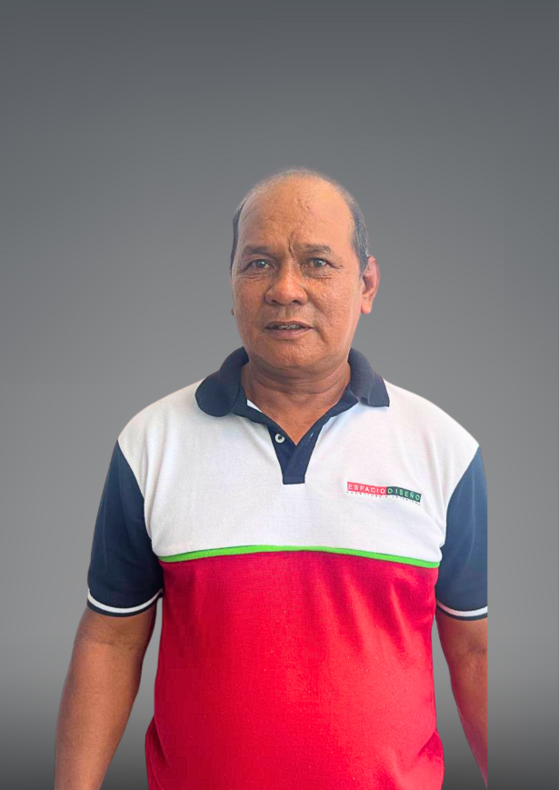 | “Malaki ang pasasalamat ko sa Espacio Diseño Inc. dahil malaki ang naitulong nila upang mataguyod ko ang aking pamilya. Dito ko lang din naramdaman ang magagandang benepisyo para sa mga empleyado. Higit sa lahat, masaya magtrabaho sa Espacio Diseño Inc. dahil lahat kami ay maganda makitungo sa isa’t-isa.”  [I am grateful to Espacio Diseño Inc. because they helped me provide for my family. This is also where I felt the good benefits for the employees. Most of all, it is nice to work in Espacio Diseño Inc. because all of us treats each other well.]  -Ricardo Mergal, Installer

